Handling File Uploads

//Locating 'browse' button

WebElement browse =driver.findElement(By.id("uploadfile"));

//pass the path of the file to be uploaded using Sendkeys method

browse.sendKeys("D:\\SoftwareTestingMaterial\\UploadFile.txt");

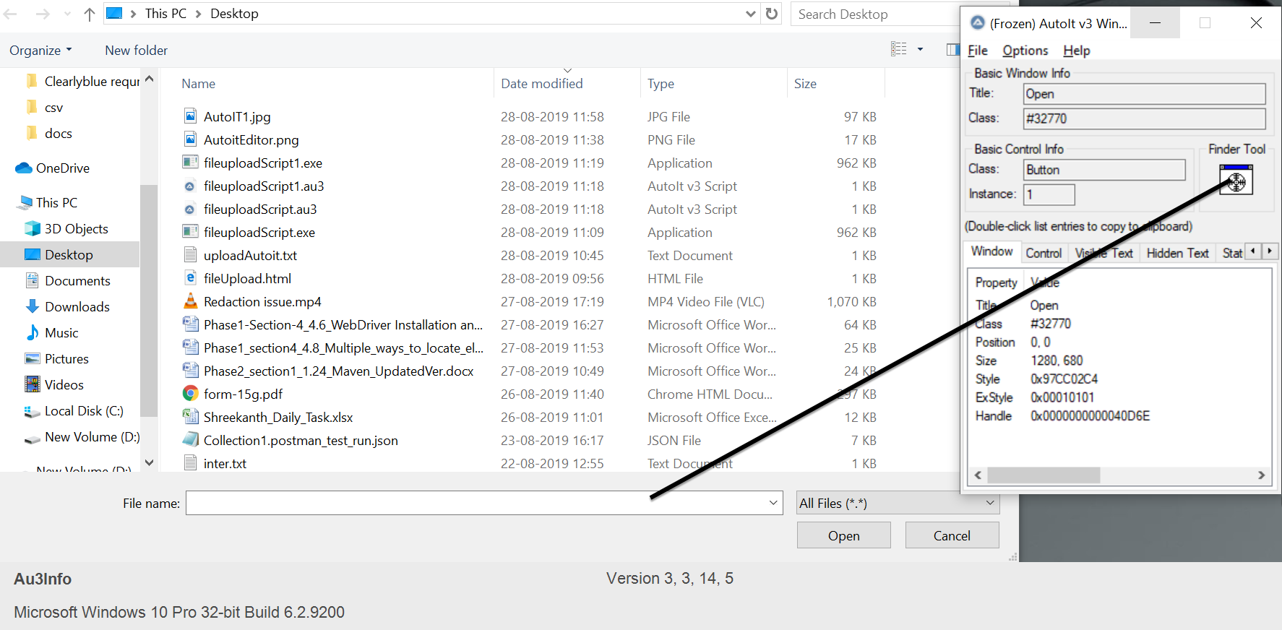

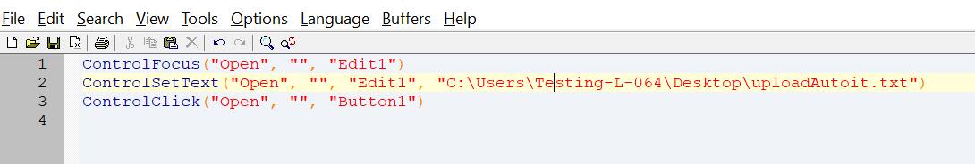

import java.io.IOException;

import java.util.concurrent.TimeUnit;

import org.openqa.selenium.By;

import org.openqa.selenium.WebDriver;

import org.openqa.selenium.firefox.FirefoxDriver;

public class AutoIt {

private static WebDriver driver = null;

public static void main(String[] args) throws IOException, InterruptedException {

driver = new FirefoxDriver();

driver.manage().timeouts().implicitlyWait(10, TimeUnit.SECONDS);

driver.get("http://toolsqa.com/automation-practice-form");

driver.findElement(By.id("photo")).click();

Runtime.getRuntime().exec("D:\AutoIt\AutoItTest.exe");

Thread.sleep(5000);

driver.close();